Incident Response Report
Case ID: SOC336
Analyst | Ahmed Emad Nasr
Date | February 4, 2025
Severity | Critical
Verdict | True Positive

--------------------------------------------------
1. Executive Summary
--------------------------------------------------
On February 4, 2025, at 04:18 PM, the SOC detected a Critical Remote Code Execution (RCE) exploitation attempt via a malicious email attachment.

The alert (Event ID: 314) was triggered by a weaponized RTF file exploiting CVE-2025-21298, a Windows OLE Zero-Click vulnerability.

Threat intelligence validation confirmed:
- The file hash is malicious and mapped to a known exploit.
- The source IP address is associated with malicious infrastructure.

The email was successfully delivered (Device Action: Allowed), indicating potential exposure.

Final Assessment: True Positive
Risk Level: Critical (Possible code execution without user interaction)

--------------------------------------------------
2. Alert Details
--------------------------------------------------

[General Information]
Rule Name: SOC336 - Windows OLE Zero-Click RCE Exploitation Detected
Event ID: 314
Timestamp: Feb 04, 2025 – 04:18 PM
Severity: Critical
Event Type: Malware
Device Action: Allowed

[Email Metadata]
Sender: projectmanagement@pm.me
Recipient: Austin@letsdefend.io
Subject: Important: Action Required for Upcoming Project Deadline

[Network Information]
Source IP: 84.38.130.118

[File Artifact]
Filename: mail.rtf
SHA-256: df993d037cdb77a435d6993a37e7750dbbb16b2df64916f99845b56aa9194184

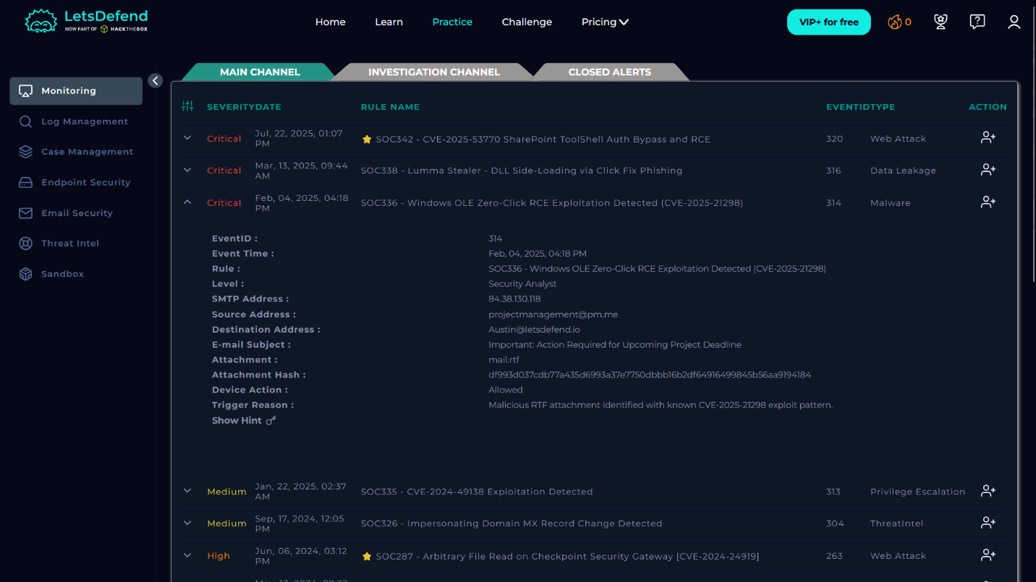3. Investigation & Analysis
--------------------------------------------------

[3.1 Phishing & Social Engineering Analysis]
- Generic external sender address
- Urgency-based subject line
- Suspicious attachment (RTF)

MITRE ATT&CK:
T1566 - Phishing

[3.2 File Hash Analysis]
Result: Confirmed malicious
Classification: Exploit.CVE-2025-21298

Conclusion:
The file is a weaponized exploit, not a legitimate document.

[3.3 Source IP Analysis]
IP: 84.38.130.118
Result: Malicious

Conclusion:
Associated with attacker-controlled infrastructure.
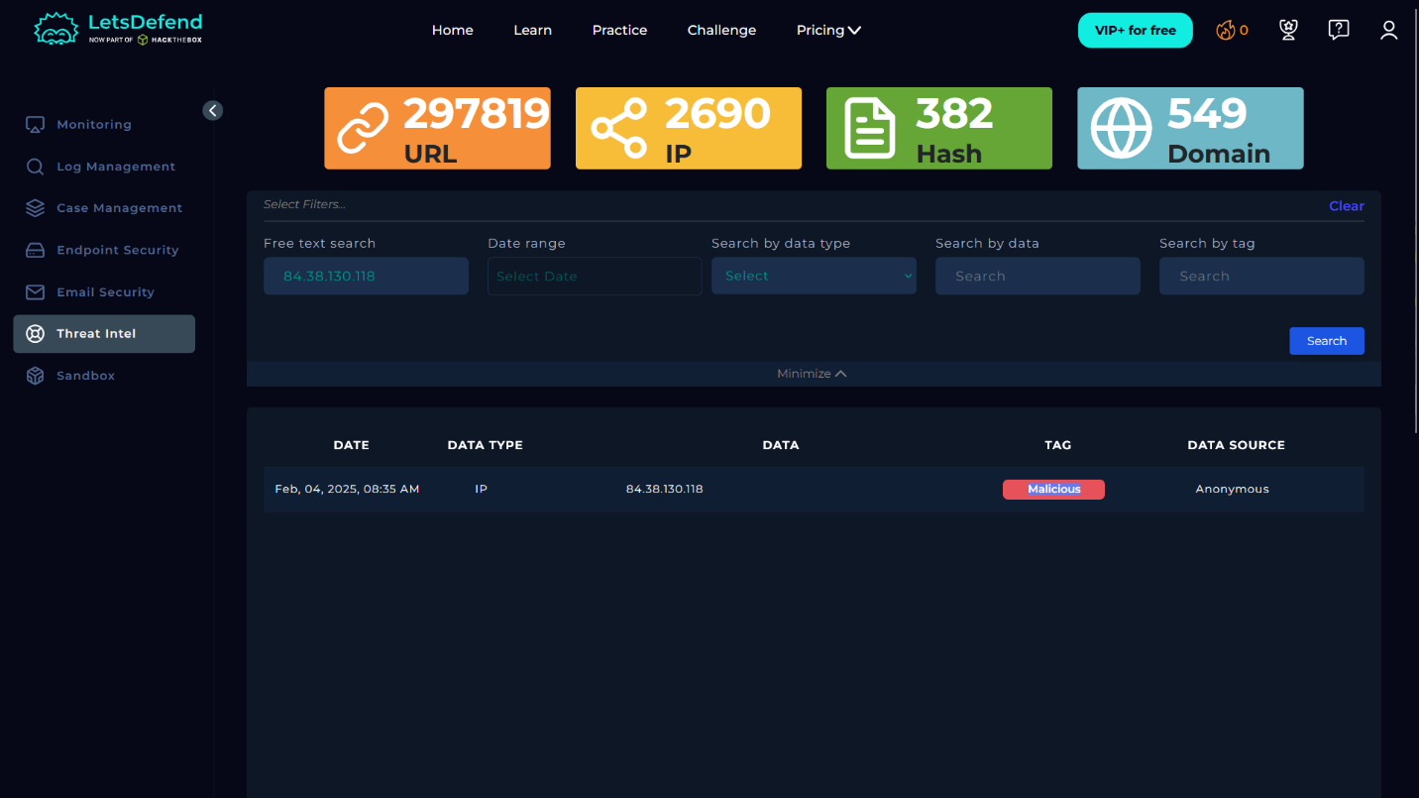

[3.4 Exploit Behavior]
- Targets Windows OLE (Object Linking and Embedding)
- Zero-click Remote Code Execution
- Can trigger via preview pane (no user interaction required)
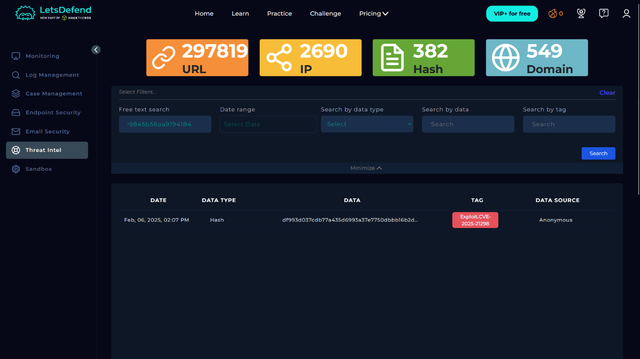

--------------------------------------------------
4. Incident Classification
--------------------------------------------------
Type: Malware / Exploitation Attempt
Vector: Phishing Email
Technique: Zero-Click RCE

MITRE ATT&CK Mapping:
T1566 - Phishing
T1203 - Exploitation for Client Execution

--------------------------------------------------
5. Impact Assessment
--------------------------------------------------

[Risk Factors]
- Email delivered successfully
- Zero-click execution possible
- Known malicious infrastructure

[Potential Impact]
- Unauthorized system access
- Malware execution
- Lateral movement
- Data exfiltration

Impact Level: High to Critical

--------------------------------------------------
6. Response Actions
--------------------------------------------------

[Containment]
- Isolated affected endpoint (Austin's machine)
- Blocked network communication

[Eradication]
- Deleted malicious email from:
* User inbox
* Mail server (organization-wide)

[Prevention / Hardening]
- Blocked IP: 84.38.130.118
- Blacklisted sender: projectmanagement@pm.me
- Added hash to EDR blocklist

[Detection Improvement]
- Updated SIEM rules for:
* RTF exploit detection
* OLE-based attacks

[Endpoint Investigation]
- Performed:
* Memory analysis
* Process inspection
* Network connection review

[Note]
Update findings if compromise is confirmed.

[Vulnerability Management]
- Emergency patch deployment for CVE-2025-21298
- Verified patch compliance across all endpoints

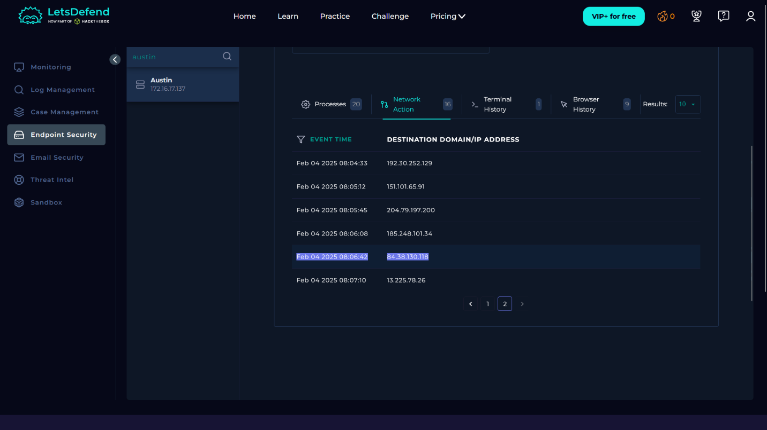

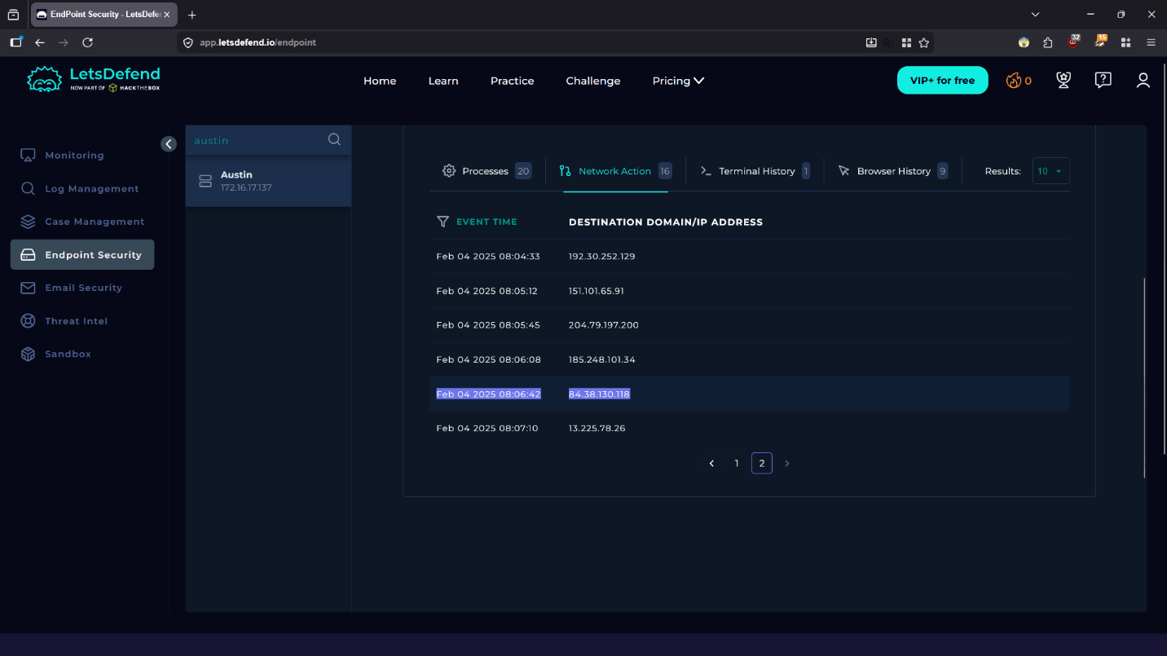
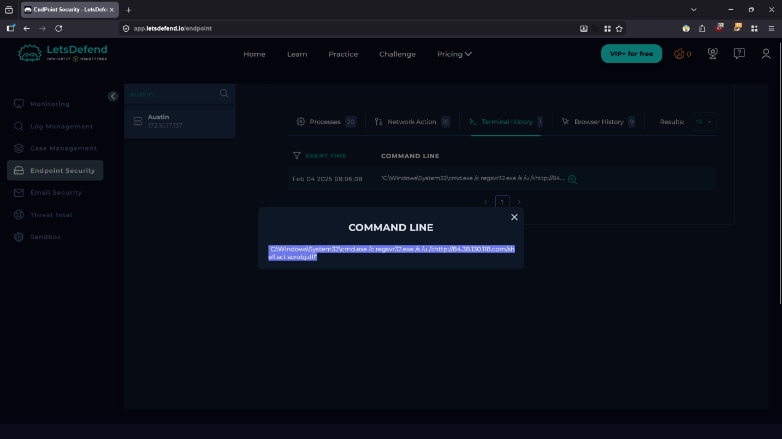

7. Lessons Learned
--------------------------------------------------
- Email gateway failed to block malicious attachment
- Need stronger SEG filtering policies
- Improve threat intelligence integration
- Increase awareness of zero-click vulnerabilities

--------------------------------------------------
8. Final Verdict
--------------------------------------------------
True Positive – Confirmed Exploitation Attempt

This incident represents a high-confidence attack leveraging a known vulnerability and malicious infrastructure.

Immediate response actions successfully reduced the risk of compromise.

==============================
END OF REPORT
==============================

